Simulation

We performed a simulation using the LTSPICE software, which had 2 benefits:
1. It allowed us to obtained the theoretically idealised waveforms.
2. It provided a clear schematic for us to follow in putting together our converter.

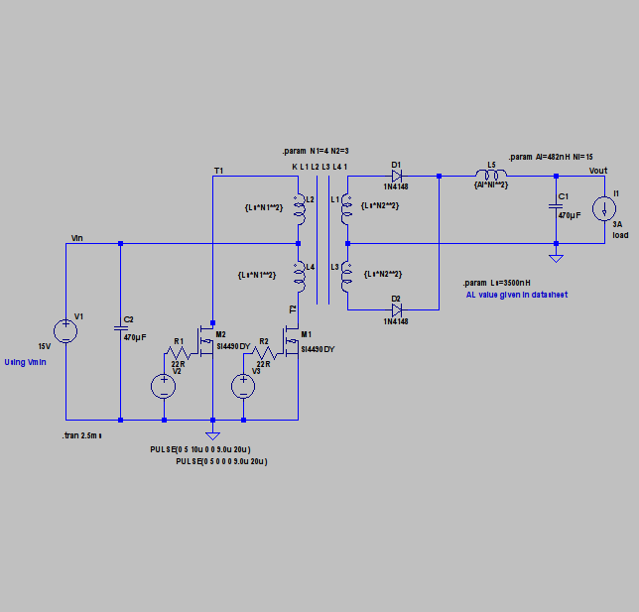
The limitation of the SPICE software was that we could not find a way for to model transformers accurately. The exact values we obtained during our simulation did not match actual test values. It provided an estimate that we still found helpful.

Analysis and Comparison of Waveforms

In this section, we will observe the various waveforms and values we have obtained in testing our converter and compare them to the ideal values, both theoretically and as specified in the design requirements.

1. Voltage and Current across MOSFETs (T1 and T2)
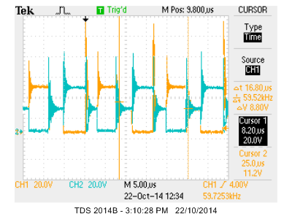

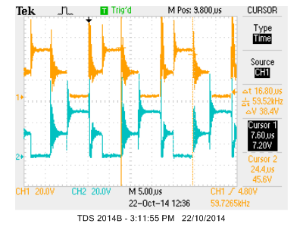

The two figures above show the voltages across the switches (MOSFETs) to the primary coil, both together and apart. It can be seen that they match the ideal waveform, as shown below, quite closely.
Also noteworthy is the switching frequency that we have measured at 59 kHz which is slightly higher than the 50 kHz that we were aiming for.

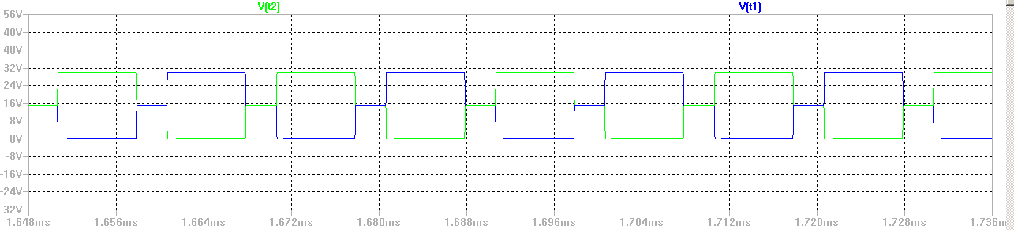
We don't have the correct waveform for the current across the MOSFETs, take from others?

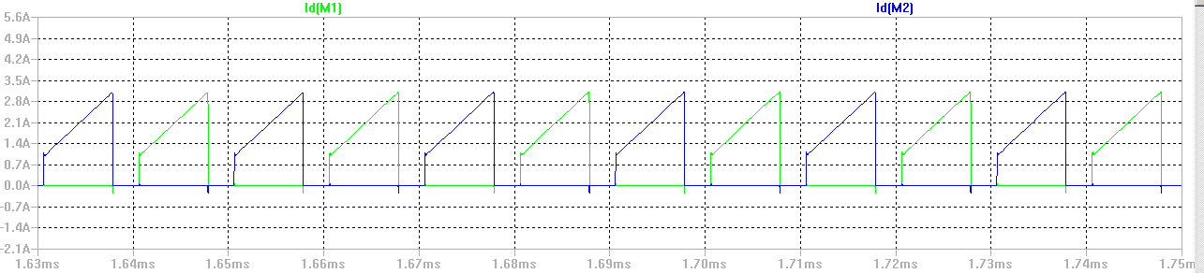
Ideal waveforms for the current flowing across both MOSFETs.

2. Efficiency Calculation

In order to determine the efficiency of our converter, we obtained these four values:
Note: Observations were performed with a 3 Ohm load.

V_{in} = 21.5 V
I_{in} = 1.47 A
V_{out} = 8.77 V
I_{out} = 2.98 A

Calculations:
P_{in} = V_{in} * I_{in} = 31.605 W
P_{out} = V_{out} * I_{out} = 26.1346 W

Efficiency = (P_{out} / P_{in}) * 100%
= 82.7%

The design specifications called for > 75% efficiency which we managed to satisfy.

3. I_{out}
We managed to achieve a value that was very close to 3 A (~2.98 A) across a 3 Ohm load while varying our input current from 15 V to 28 V.
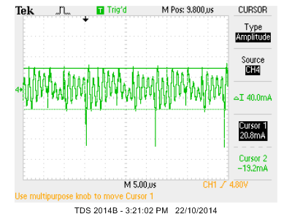

The figure above shows the ripple of the output current, which is about 40 mA.
this part may be unnecessary

4. V_{out}
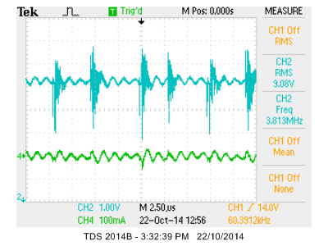
V_{out} in Blue
I_{out} in Green

This particular snapshot of the voltage waveform was taken at an input voltage of 21.5V, around the middle of our input range.
As can be seen, we have successfully achieved an output voltage of 9V which was required of us in the design specifications. This RMS value remained steady with a small variation of +- 0.1V when we varied the input voltage from 15 – 28 V.
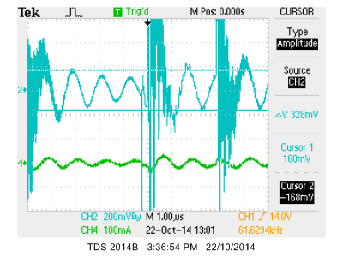

The figure above shows the same two waveforms, zoomed in. Using the cursor, we measured out output ripple voltage at 328 mV which satisfies the requirements.

5. Current across diodes

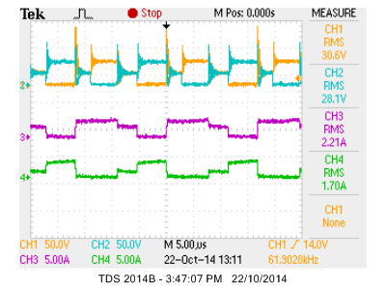
The blue and yellow waveforms represent the voltage across the MOSFETs, used as a reference.
The purple and green waveforms represent the current across the secondary diodes.

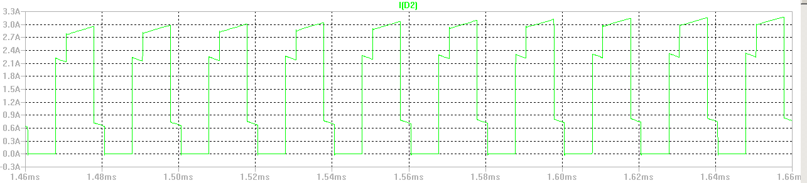
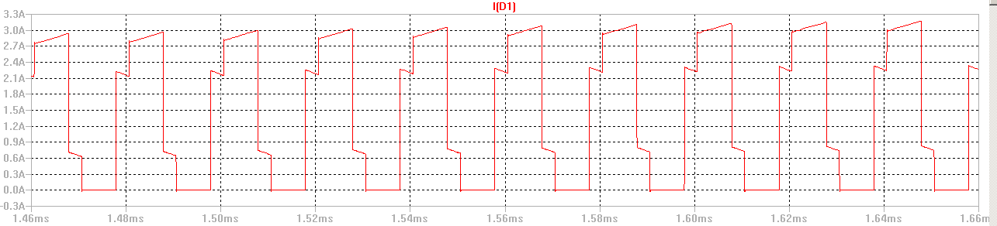
The ideal waveforms show a symmetry between the two diodes (except out of phase). Our observed waveforms seem to be slightly erroneous in that one of the diode currents is wider than the other (purple > green). We suspect that this is due to one of the diodes reacting faster than the other.

6. Current across Inductor (I_{L})

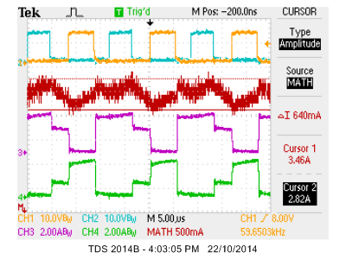

The red waveform is the addition of the two diode voltages (I_{D1} + I_{D2}) which should combine to give us the current across the inductor. Due to the resolution being poor, we have measured the inductor current directly shown in the figure below.

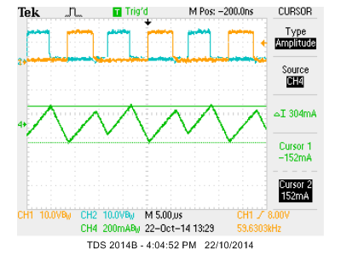

The inductor current is shown in green and has a ripple of 304 mA measured using the cursor, which is within specifications.

